Group Name:

Ideal Gas Constant
Experiment Design

LibreTexts page: 8: Gases

(https://chem.libretexts.org/link?214685)

Please don’t edit, rearrange or delete anything that is already in this document. Just add your answers inside the boxes.
You can use shortcuts for superscripts and subscripts when needed:
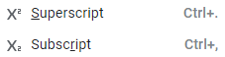

The objective of this exercise is to design an experiment to determine the value of the Ideal gas constant from Boyle's Law Data. We have access to a Vernier Pressure Probe hooked to a Raspberry Pi (figure 1).

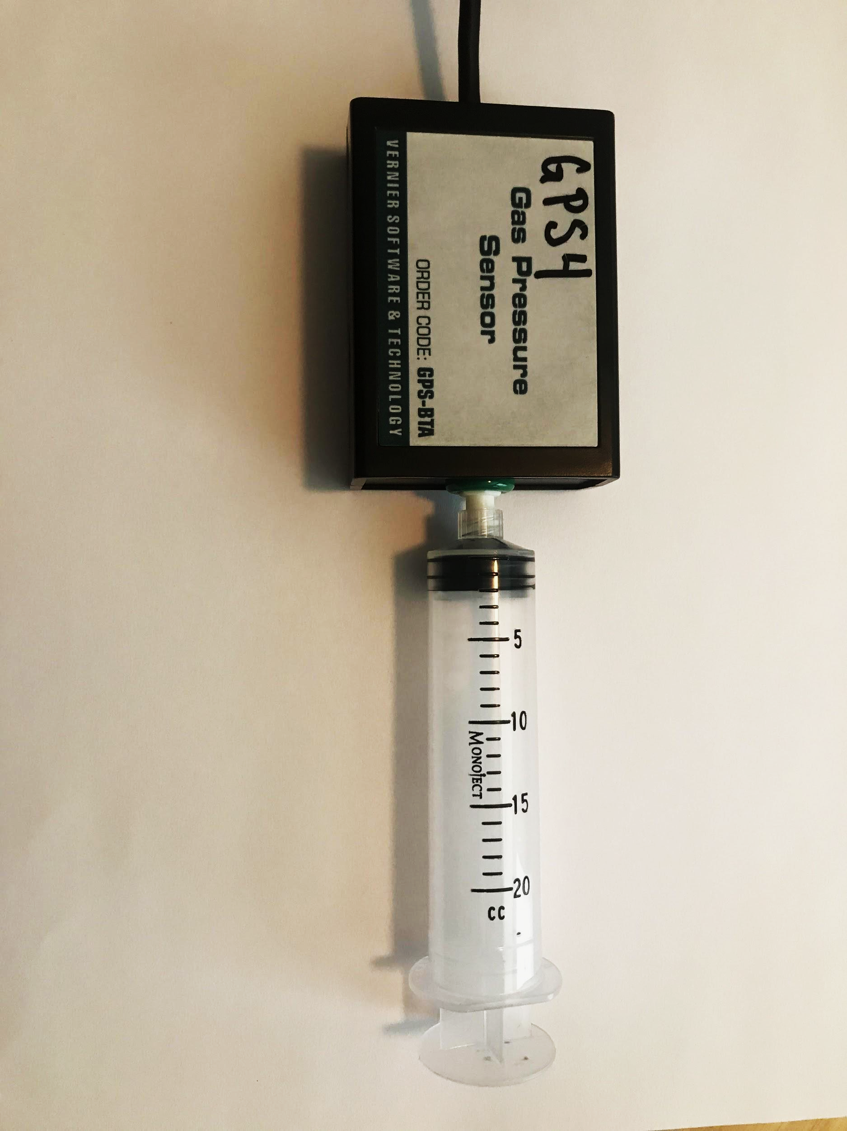
Figure 1: Pressure Sensor with syringe

This is a "closed system" in that no gas can enter or escape, and so the number of molecules (n) is constant. In this experiment we will expand the volume of the gas by moving the plunger on the syringe, and do this slowly so the temperature will equilibrate and stay constant, causing the pressure to adjust to the new volume. In this experiment Pressure is the dependent variable and volume is the independent variable, that is, pressure is a function of volume (we change the volume and then read the new pressure).

Experimental Design

Part I: Boyle's Law plot
Part II: Determine the volume of Air when Syringe reads zero
Part III: Determine the moles of gas in the syringe
Part IV: Determine the Ideal Gas Constant

Part I: Boyle's Law plot

Quickly describe how using the apparatus in Figure 1 you would acquire data for a Boyle's Law plot. You may want to watch the first 30 seconds of this YouTube video (https://youtu.be/O2QQMqaJYCk). Note, unlike the video, we will start with the syringe reading zero volume (at atmospheric pressure) and expand the syringe's volume, reading the pressure as a function of the volume.

Describe what you would plot to get a straight line, that is a linear plot where the pressure is a function of the volume.
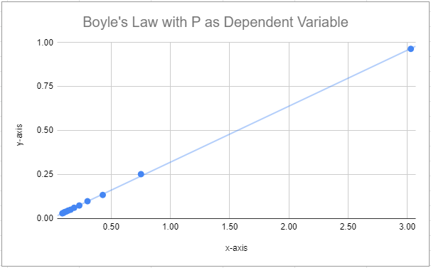
For the above graph indicate what type of data is plotted on the x and y-axis and be sure to include units.

x-axis:
y-axis:

Part II: Determine the volume of Air when syringe reads zero

If you look at figure 1 it should be clear that even though the scale reads zero volume, this is not the true volume and there is a gas volume between the seal and the pressure sensing unit. You need to figure how to use Boyle's Law to calculate this volume, that is, what is the actual volume when the scale reads zero.

Hint: You know the pressure when it "reads" zero, and you can figure out how the pressure would change if the volume doubles.

Part III: Determine the moles of gas in the syringe

- To calculate n we will use the two state approach, where one state is a mole of gas at STP. Fill in the values for State 2 in the table below.
Hint: go to Section 10.2.4 (https://chem.libretexts.org/link?52148).
State 1 (our gas) |  | State 2 (STP)
T₁ | Will be given | T₂
V₁ | Calculated in Part II | V₂
P₁ | Room pressure | P₂
n₁ | Solve below | n₂ | 1 mol

- Algebraically solve for n₁ using equation 10.2.18 that you can find here.

Part IV: Determine the Ideal Gas Constant
Show how the slope of the line in a Boyle's law plot can be used to calculate the ideal gas constant R.

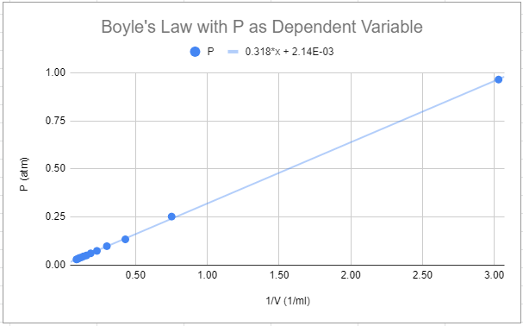

Equation 10.2.3 of LibreText section 10.2.2.1 shows the relationship between the slope of the line and R, but beware, your graph will look like the above image and show P as the dependent variable, while the graph in figure 10.2.2 of LibreText shows V as the dependent variable. Note, the slope of the line has units, which can be determined from the above graph.

