Group Name:

VSEPR
Group Lab Report

LibreTexts page: 7: Molecular Structure

(https://chem.libretexts.org/link?214684)

Please don’t edit, rearrange or delete anything that is already in this document. Just add your answers inside the boxes.
You can use shortcuts for superscripts and subscripts when needed:
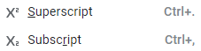

Use the VSEPR Worksheet to answer the questions.
To indicate the dipole, ROTATE the image to position atoms with partial positive charge on top.
Use the first compound as example.
Compound | Name electronic geometry and identify hybrid orbitals | Name molecular geometry, indicate bond angle and if polar. Paste the image and orient it so partial positive charge is at the top.
H₂O | Tetrahedral, sp3 | 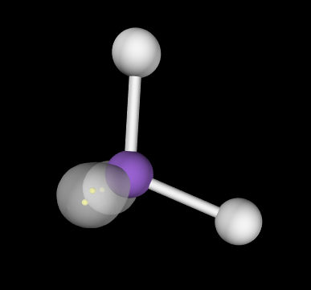  Bent, 104.5 deg, polar
NH₃
NH₄⁺
SO₂
NO₃⁻
SeCl₄
AlCl₃
XeCl₄

