Group Name:

Lewis Dot Structure
Group Lab Report

LibreTexts page: 7: Molecular Structure

(https://chem.libretexts.org/link?214684)

Please don’t edit, rearrange or delete anything that is already in this document. Just add your answers inside the boxes.
You can use shortcuts for superscripts and subscripts when needed:
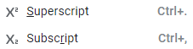

For each compound*:
- Draw Lewis Dot Structure and any resonance structures. Take a picture of it and insert it in the table. Resize as needed.
- Calculate formal charges of atoms. Show calculations for partial credit.
Hint: go to https://chem.libretexts.org/link?52857

*Use water as an example.

Compound | Lewis Dot Structure, Resonance structures | Formal charge of atoms
H₂O | 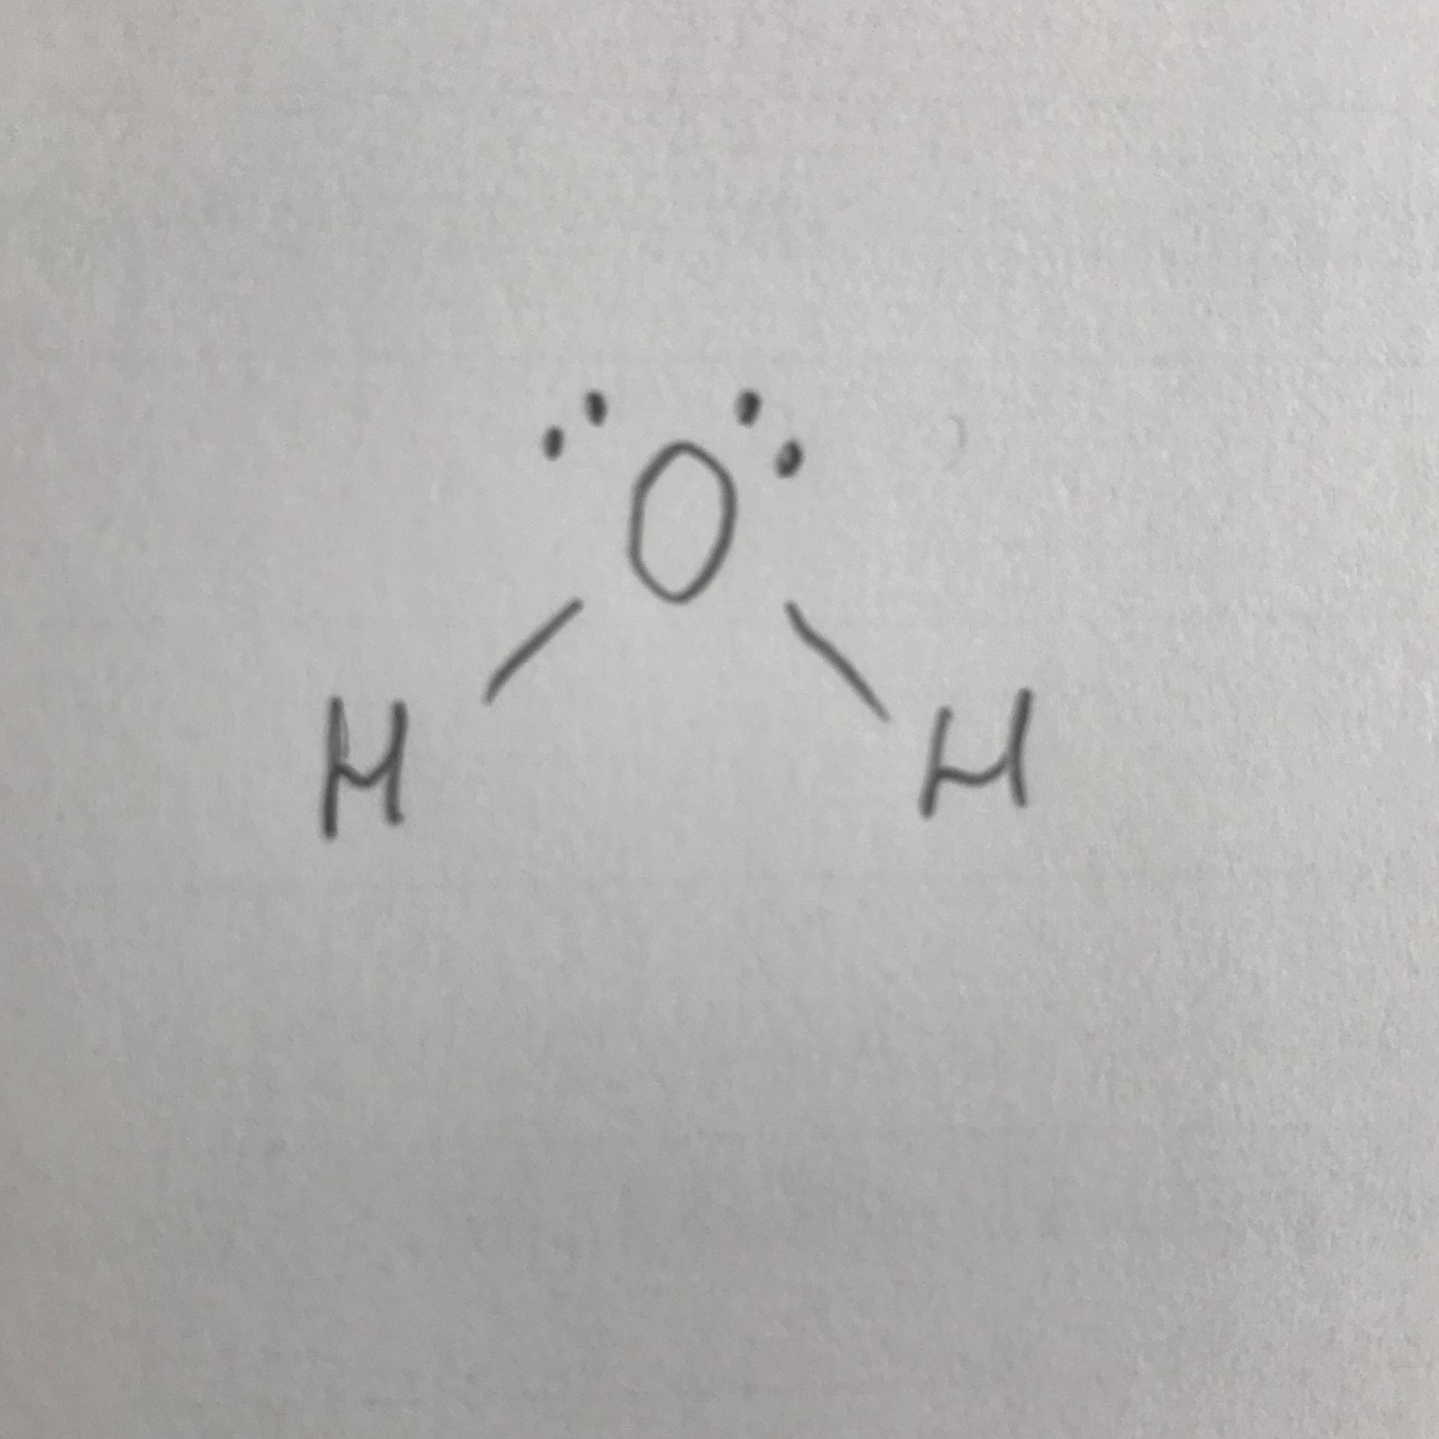 | O = 6 - 4 - (4/2) = 0  H = 1 - 0 - (2/2) = 0
NH₃
NH₄⁺
SO₂
NO₃⁻
SeCl₄
AlCl₃
XeCl₄

