Group Name:

VSEPR Worksheet

LibreTexts page: 7: Molecular Structure

(https://chem.libretexts.org/link?214684)

Use PhET Simulation (see link below) to build electronic orbital models. Take screenshots and insert them in the table. Name the geometry.
Use snipping tool or take a screenshot and insert in the table. Resize as needed.
Use ONLY lone pairs.
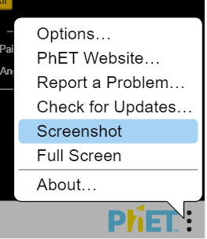

Steric # | Screenshot | Electron Geometry
2
3
4
5
6

