Name:

Specific Heat Capacity
Lab Report

LibreTexts page: 5: Calorimetry

(https://chem.libretexts.org/link?214682)

Please don’t edit, rearrange or delete anything that is already in this document. Just add your answers.
You can use shortcuts for superscripts and subscripts when needed:
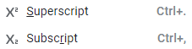

If you want partial credit for your answers, show your work in the calculations section.

Part I
In this lab you will design an experiment to calculate the specific heat capacity of an unknown metal using Carnegie Mellon’s Chemcollective’s Virtual lab (http://chemcollective.org/activities/vlab/68)

The above lab was designed to calculate the density of an unknown metal. You need to change this to calculating the specific heat capacity of your assigned metal. The general strategy is to heat the metal to a known initial hot temperature, drop it into cold water at an initial cold temperature, and read the final temperature.
Write in the box below the algebraic equation that describes the first law for heat transfer from a hot object to a cold object, be sure to use subscripts.

Solve the above equation for the specific heat capacity of the hot object.

You now need to start getting the known values to calculate the specific heat capacity of the metal, and should be writing this in the data table of part 2.

It is suggested you use a 1000 ml beaker for the hot metal and a 1000 Erlenmeyer flask for the cold water

Cold water: This is tricky, you need to fill a 50 mL burette and then transfer water to the 1000 ml Erlenmeyer Flask. It is suggested you transfer around 25 mL. But before you do that, you need to weigh the mass of the empty beaker
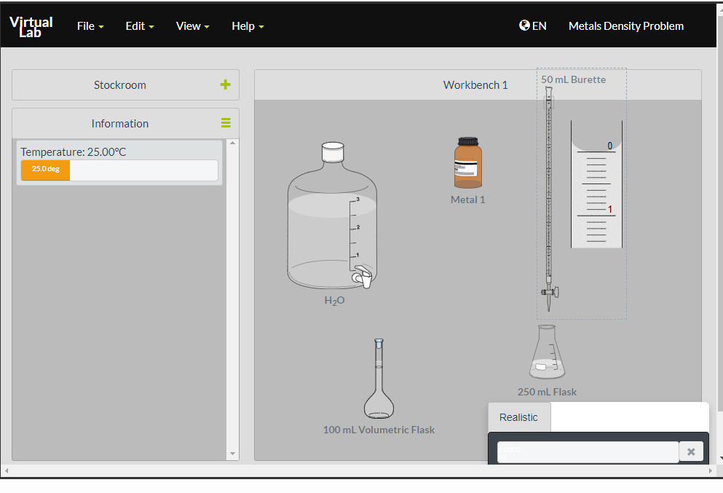
A burette is a TD (To Deliver) device and so the scale reads from top to bottom.
Mass Empty Flask
Mass Flask Plus Water
Mass Water
Temp Cold Water

To adjust the temperature you should right click on the beaker, choose a Temperature and insulate from surroundings. This will function as your calorimeter.
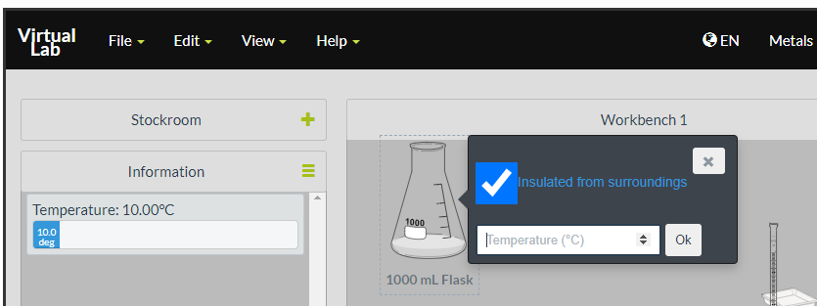

Now using a 1000 mL beaker repeat the above but set the temperature to a high temperature. When you add the metal just click once and then weigh.
m.
Mass Empty Beaker
Mass Beaker Plus Metal
Mass Metal
Temp Hot Metal

Now pour the hot metal into the cold water and record the final temperature

Part II

- What is your metal # (1, 2 or 3)?

- Data table

m_{C}
T_{C}
c_{C}
m_{H}
T_{H}
T_{F}

- Calculations (Include explanations for partial credit)

ΔT_{C}
ΔT_{H}
c_{H}

