Group Name:

Gravimetric Analysis
Worksheet

LibreTexts page: 4: Chemical Reactions

(https://chem.libretexts.org/link?214153)

Please don’t edit, rearrange or delete anything that is already in this document. Just fill in the answers.
Shortcuts for superscripts and subscripts:
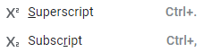

This is the first Virtual Lab of the semester. Your goal is to become familiar with the virtual lab that was developed by the Chemcollective of Carnegie Mellon University and then use the lab to determine the lead concentration of an unknown solution.

Part I

1. Unknown Assignments: Each group is to identify the concentration of their unknown lead solution.

Group name | Unknown
 | Solution B
 | Solution C
 | Solution D
 | Solution E

2. Review LibreText section on gravimetric Analysis of Lead using sodium phosphate (https://chem.libretexts.org/link?51456). In that section they added sodium phosphate to an unknown lead solution and precipitated out lead (II)phosphate. You will use the virtual lab and sodium chloride.

3. Watch the following video to become familiar with the virtual lab
(http://www.chemcollective.org/chem/common/vlab_walkthrouh_html5.php).

4. You may wish to review the solubility rules before designing this experiment. In addition to your unknowns, the "Gravimetric Analysis Lab" contains 2M potassium chromate and 4M sodium chloride. You are required to use 4M sodium chloride. Also, the aqueous species viewer has been disabled and the solid species viewer has been enabled, this allows you to determine the mass and identity of any precipitates formed, but prevents you from directly reading the concentrations.

Go to Virtual Exercise 4.7.1, which uses potassium chromate to calculate the lead concentration and adopt these to the use of sodium chloride. You may also want to analyze the data in Exercise 4.7.1 Arsenic in Ground Water.

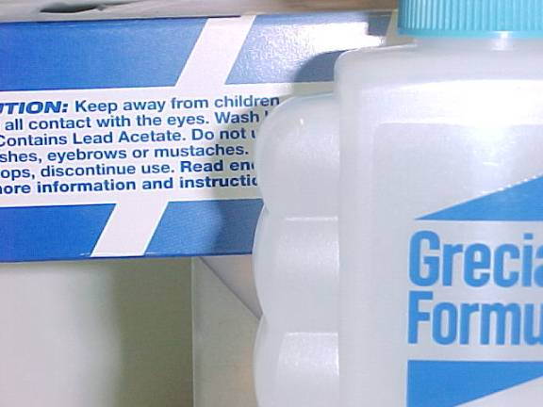
5. In 1980 lead(II)acetate was listed as safe for use in cosmetics like hair color products has been used in products like Grecian Formula (Figure 4.7.2), and the FDA repealed is approval for use on October 30, 2018 for health concerns with the ban supposed to go into effect on December 3, 2018. The ban had a 30 day appeal period for anyone "adversely affected" by the ban and the manufacturer, Combe company requested a hearing claiming it was safe, and now the ban is on hold until this is resolved (see the US FDA announcement and Jan. 9, 2019 Consumer Report).

Part II: GROUP ASSIGNMENT

- Explain how you were able to determine that all the lead was removed from the water. [You MUST use the following keywords in answering this question: sodium chloride, lead chloride, Pb⁺²(aq), precipitate, limiting reagent, excess reagent]

- Report the concentration of the lead ion in your unknown solution in units of grams per liter.

- Report the concentration of the lead ion in your unknown solution in units of molarity.

Part III: INDIVIDUAL ASSIGNMENT

You will be assigned Unknowns individually via email. Make sure to check it prior to this lab.

Student 1 | Type your name here
Unknown

Report the concentration of the lead ion in your unknown solution in units of molarity.

Student 2 | Type your name here
Unknown

Report the concentration of the lead ion in your unknown solution in units of molarity.

Student 3 | Type your name here
Unknown

Report the concentration of the lead ion in your unknown solution in units of molarity.

Student 4 | Type your name here
Unknown

Report the concentration of the lead ion in your unknown solution in units of molarity.

Student 5 | Type your name here
Unknown

Report the concentration of the lead ion in your unknown solution in units of molarity.

