Hypothes.is Assignment: (2 pts) Make an annotation on a resource that assisted you in performing this assignment.

Individual Homework Activity (20 pts):

Write a program the prompts the user for information for three students. For each student prompt for the student ID and three quiz grades. Use a nested loop, where the inner loop prompts for the three quiz grades. Print the student’s name and average – formatted to two decimal places. View the sample output as a guide.
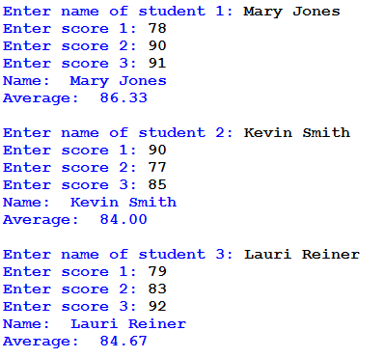
Your program must contain documentation lines that include your name, the date, a line that states “Py10 Individual Homework” and a description line that indicates what the program is supposed to do. Take a screenshot of the program and its output and attach to this document. Upload this document and the program to Google Drive.

