Hypothes.is Assignment: (2 pts) Make an annotation on a resource that assisted you in performing this assignment.

Individual Homework Activity (20 pts):
Please place your code for each step in a single file (yourlastname_py09.py) and submit it to the Google Drive.

The homework has three steps, and each step should be its own function in your python program.

Step 1: Writing to a File in the Current Folder

Convert your program that converts the temperature in Celsius to Fahrenheit. This time, using a function called convertOutput(), have the program output the two pieces of data to a txt file. For each line in the data file, you should have a temperature in Celsius, and the second in Fahrenheit. The first line of data in the file should be Celsius, Farhenheit (see sample output below). Write the data to a file named temperatures.txt. In the file you should have all integer values of Celsius from 0 to 100 in 5 degree increments.

Test your program by running it and when the program ends, open the file the program wrote to by double-clicking it. What’s in the file? If you don’t see your list of temperatures, then you have done something wrong and should go fix your program.

Step 2: Reading from a File in the Current Folder

Now add a function called outputData() to your program to read data from the temperature file your program wrote. Can you read data from a file that wasn’t written by your program? YES!!! But having you read from a file you already created saves us the step of having you make a new file. Print out the data to the screen that is read in from the file. Use rstrip() to remove unsightly extra line feeds.

Step 3: Copying from One File to Another File in the Current Folder

Add a function called copyFile() that asks for a new file name as an argument, reads the data from temperatures.txt, and writes the data to the new file. Make sure it worked by checking the new file!
Your program must contain documentation lines that include your name, the date, a line that states “PA9 Individual Homework” and a description line that indicates what the program is supposed to do. Take a screen shot of the program and the output and attach the files (PA9_yourname.py, temperatures.txt, copyfile.txt and screenshots) to homework python activity 9 in Moodle. (15 points)

Sample output for 4 degree increments:
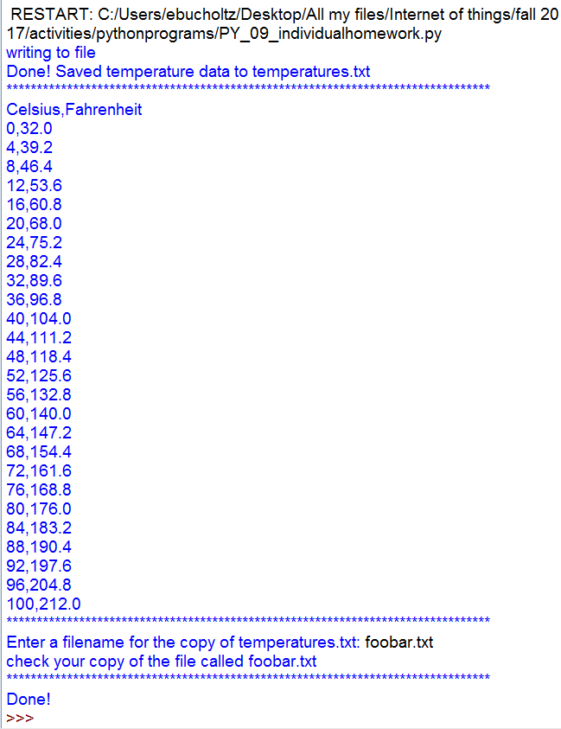 | 