1. Make one Hypothes.is annotation on an external source dealing with ESD (electrostatic discharge) (2 pts)

For python program to insert input statements that ask you to input your message, who you want to send the email to, and what attachment you wish to include. The functionality is shown below

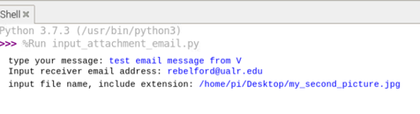.
Paste the code to the end of this document and upload the python file with the filename" YOURLASTNAME_IOT03.py

2. Take a picture with your Pi and send it to your professor through the program you made in question 1. Note, if the picture is in a different folder than the python program you can include it's path. If you ever need the path of a file and you are using on your Pi desktop, you can right click on the file and choose "Copy Path(s)" (15 pts)

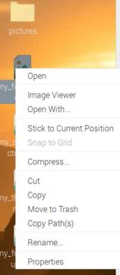

3. Systems Call: Running a non-Python program in Python.
In this assignment you will call a Bash script of sending an email in Debian from Python.1

1. Go to Appendix 3.34 sending email
a. Install msmtp
b. Install mutt
c. Create msmtp config file
d. Create mutt config file
e. Create email file
2. Send an email through the command line (the code is in Appendix 3)

3. Open Thonny and create a program that sends an email through msmtp and mutt, the same way you ran

