2 pts: Make one Hypothes.is annotation on an external source concerning the content of this chapter and tag it s20iostpy08ualr

Individual Homework Activity: (20 pts) Write a program that converts the temperature in Celsius to Fahrenheit. Have the program output two columns that are aligned like below. In the first column, it prints out the temperature in Celsius, and the second in Fahrenheit. Have the data print out all integer values of Celsius from 0 to 100 in 3 degree increments. Have the data print out the Fahrenheit to 1 decimal point.
Your program must contain documentation lines that include your name, the date and a description line that indicates what the program is supposed to do.

Sample output (in 4 degree increments for Celsius):
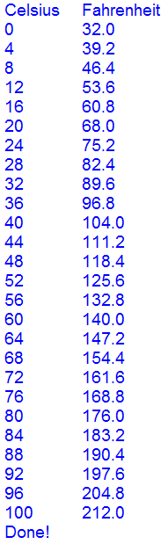

- Using your Raspberry Pi and Cobbler, build a circuit with a red LED. Assign the LED to GPIO 17. Write a program that uses a FOR loop that starts the light with a value of 0 (completely off) to a value of 1(completely on) in 0.01 increments. Each time the light increases in intensity, the program should wait for 0.1 seconds. Therefore it should take 10 seconds to go from off to full intensity.

Submit your python programs to homework IoT_08 in Moodle. Take videos of your circuits working showing successful completion of the homework problems. Upload this video to YouTube (you can make it private) and include the youtube link in your documentation lines. Your programs must include documentation lines that include your name, the date, a line that states “PA8 Individual Homework program 2”, and a line that states what the program is supposed to do. (10 points)

