2 pts: Make one Hypothes.is annotation on an external source concerning the content of this chapter and tag it s20iostpy07ualr

Individual Homework Activity: (20 pts)

In this homework, we are going to learn the benefit of reusing code, the value of commenting code, and apply new functionality to a program.

Recall the program you wrote for Python Activity 4 that calculated the Henderson-Hasselbalch equation.
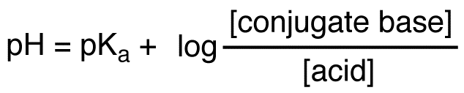
Chances are at this point, you probably don’t recall what all your variables do or what each part of the code does. We can correct this by adding comment statements throughout the code.

The pKa of acetic acid is 4.76. Modify your previous program to calculate the pH of a solution of sodium acetate and acetic acid.

- Have comment statements to indicate what each part of the program does
- Calculate pH values until the user indicates they don’t want to calculate another value.
- Asks for a value for the concentrations of your conjugate acids and bases between 0.000 and 1.000 M.
- If the value is out of range, asks them to input a value that is within that range.
- Your program should then tell you what the pH of the solution is.
- Your output should report numbers to 3 decimal places.
- Your program should have a way to allow the user to exit out gracefully by indicating they don’t want to calculate another solution pH.

Your output should look like:
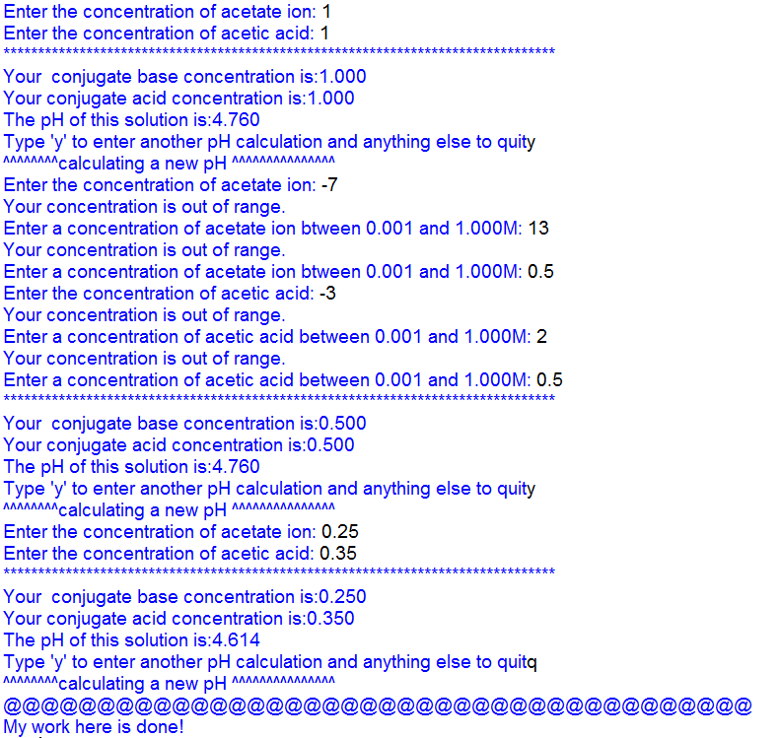

Programming hints:
Look at all code written in class so far and reuse!
Some things work well as user defined functions as we are testing multiple things over and over.
Upload to Google Drive:
- This word document with your code and name on it, labeled [your last name]_py07_HW
- Your python program labeled [your last name]_py07 Program
- As always, 2 hypothes.is annotations, tagged s20iostpy07ualr

