2 pts: Make one Hypothes.is annotation on an external source concerning the content of this chapter and tag it s20iostpy05ualr

1. Write a Python program that prompts the user for the cost of two items to be purchased. Then prompt the user for their payment. If they enter an amount that is less than the total cost of the two items, print a message that tells them how much they still owe. Otherwise, print a message that thanks them for their payment and tells them how much change they will receive. Thoroughly test your code for all possible input. (10 pts)
Paste your code below (in this document) and upload the python file with the filename of YOURLASTNAME_PY05_Q1

2. Create a Python program that prompts the user for four test grades. It will be used to determine if a student has earned an A, B, C, D or F in the class, using the following grade cut-offs

A | >= 90%
B | 80.00-89.99%
C | 70.00-79.99%
D | 60.00-69.99%
F | <60.00

A student can drop the lowest exam score of the four exam scores. Therefore, the program should find the average of the three highest grades and print this average. It should also print a message stating the letter grade they earned in the course. Thoroughly test your program with data that calculates a grade for each letter grade. Also be sure that the lowest grade is not included in the calculation independent of whether it is the first, second, third or fourth test score entered by the user.

Hint: look up the python min() predefined function to help you. The link is in the reading for this assignment.

Sample output:

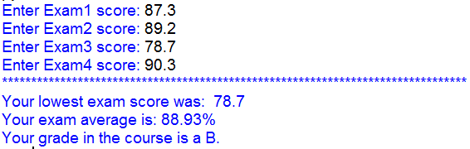
(10 points)

Paste your code below (in this document) and upload the python file with the filename of YOURLASTNAME_PY05_Q2

