Python Activity 3: Arithmetic Operations and Assignment Statements
UALR

Individual Homework Activity:

1. (5 pts) Write a Python program that prompts the user for two numbers, and then gives the sum and product of those two numbers. Your sample output should look like this:

Enter your first number:10
Enter your second number:2
The sum of these numbers is: 12
The product of these two numbers is: 20

- Your program must contain documentation lines that include your name, the date, a line that states "Py03 Homework question 1" and a description line that indicates what the program is supposed to do.
- Paste the code this word document and upload to your Google drive when the assignment is completed, with file name [your last name]_py03_HWQ1
- Save the program as a python file (ends with .py), with file name [your last name]_py03Q1_program and upload that to the Google Drive.

[Paste code for Question 1 here]

2. (10 pts) Write a program that calculates the molarity of a solution. Molarity is defined as numbers of moles per liter solvent. Your program will calculate molarity and must ask for the substance name, its molecular weight, how many grams of substance you are putting in solution, and the total volume of the solution. Report your calculated value of molarity to 3 decimal places. Your output should also be separated from the input with a line containing 80 asterixis.

Assuming you are using sodium chloride, your input and output should look like:
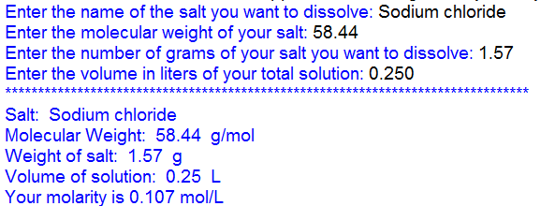

- Your program must contain documentation lines that include your name, the date, a line that states "Py03 Homework question 2" and a description line that indicates what the program is supposed to do.
- Paste the code to question two below
- Save the program as a python file (ends with .py), with file name [your last name]_py03Q2_program and upload that to the Google Drive.

[paste code for question 2 here]

3. Make two hypothes.is annotations dealing with external open access resources on formatting with the format function method of formatting. These need the tag of s20iostpy03ualr.

