Individual Homework Activity:
1. Then Henderson-Hasselbalch equation is used to calculate the pH of a solution given the pK_{a} and the concentration of acid and conjugate base. (15 pts)

The equation is:
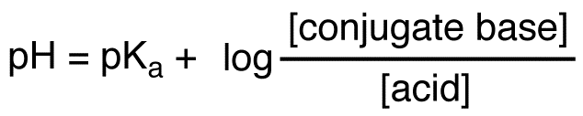

Write a program that asks for the pKa of an organic acid, and then randomly assign concentration values of the conjugate acids and bases between 0.000 and 1.000 M concentrations. Your program should then tell you what the pH of a randomly assigned solution is. Your output should report numbers to 3 decimal places.

Sample output for this program:
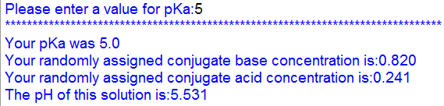
Your program must contain documentation lines that include your name, the date, a line that states "Py04 Individual Homework" and a description line that indicates what the program is supposed to do.

Hints: you will have figure out (google) how to get random floating point numbers, and how to do a log base 10 mathematical function.

2. Hypothes.is assignment, make two annotations on external content related to predefined functions in python and tag them s20iostpy04ualr (5 pts)
Upload to Google Drive:
- This word document with your code and name on it, labeled [your last name]_py04_HW
- Your python program labeled [your last name]_py04 Program

