Laboratory Project Assessment
Instrumental Analysis

Refer to the following paper to answer the questions in this assessment.
Baranowska I., Plonka J., Determination of Biogenic Amines and Vitamins in Urine Samples with HPLC, Journal of Liquid Chromatography and Related Technologies, 31:2974-2987, 2008.

(Do not begin by reading the entire paper in detail. Rather you should skim the paper for general content and then refer to specific sections of the paper as needed to answer the questions.)

Level 1: Knowledge

1. a. What was the goal of the paper? (answer in 1 sentence)
b. Why is the work important? (answer in 2-4 sentences)
c. What is the benefit of the LC analytical method described in the paper over currently existing LC methods for the analysis of vitamins? (answer in 1 sentence)
Level 2: Comprehension
Option 1: Refer the section Urine Samples
What is the purpose of passing 1 mL of urine sample through a C₁₈ SPE column?
Option 2: Refer the section High Performance Liquid Chromatography Conditions to answer parts a, b, and c.
- How is detection of vitamins and biogenic amines achieved?
- What detector and wavelengths are used to quantify the vitamins? Why is this type of detector needed for this application?
- What detector and wavelengths are used to quantify the biogenic amines?
- Explain why fluorescence emission occurs at a longer wavelength than excitation.
- What is advantage of including a fluorescence detector in addition to a DAD detector?
Option 3: Refer the section High Performance Liquid Chromatography Conditions to answer part a.
- What are the two mobile phase solvents? Which solvent is increased during gradient elution?
- What is the purpose of two solvents?
- What is the benefit of gradient over isocratic elution?
- What is the purpose of increasing the flow rate towards the end of the chromatographic run?
Level 3: Application
(Refer to Figure 1 –Chromatogram of Vitamin Standards, Figure 3(a) -Chromatogram of Urine Sample, Table 1 Calibration Curve Parameters, and the sections Calibration Curves and Urine Samples to answer the question.)
A human urine sample was prepared according the procedure given in the paper. The chromatographic peak for Vitamin B₂ (Riboflavin) had a retention time of 26.30 min a peak area of 352,540. What is the concentration of Vitamin B₂ in the original urine sample in units of µg/mL? Show all work.
Level 4: Analysis
Option 1: A standard sample of Vitamin B₂ is injected 3 times with the following results:
Injection | Peak Area
1 | 270879
2 | 221555
3 | 246831
Average | 246421
Standard Deviation | 24664

Is the level of precision suitable for quantitative analysis? Explain your reasoning.
Option 2: Imagine that in the urine sample of one individual, the Vitamin B₂ peak appears as shown below. Can the amount of Vitamin B₂ be quantified in this sample? Explain.
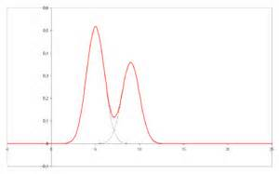
Vitamin B₂
Unknown substance

Option 3: You perform an analysis of a urine sample and find that the peak for Vitamin B₂ is visible but the peak area is below the area of your lowest standard. Can the amount of Vitamin B₂ be quantified in this sample? Explain.

Level 5: Synthesize/Modify (Options in level 5 follow the same number given in level 4. If Option 1 was chosen in level 4 question then choose option 1 in level 5 question.)
Option 1: You would like to improve the reproducibility in the peak area of replicate injections. Describe what experimental modifications you could make.
Option 2: You would like to improve the separation between Vitamin B₂ and the unknown substance shown in the chromatogram. Explain how a better separation can be achieved. You cannot change the analytical technique or HPLC column.
Option 3: You would like the peak area for Vitamin B₂ in the urine sample to fall within the range of your standards. Suggest two different experimental approaches to solve the problem.

Level 6: Evaluate
Your lab partner has been taking a vitamin supplement with high levels of vitamin B₂ (Riboflavin) and believes that most the riboflavin is not being used by the body and is simply being excreted in urine. (Your lab partner formulated this hypothesis because the urine is extremely bright yellow after ingesting the vitamin.) You and your partner decide that your independent project in Analytical Chemistry lab will be to quantify the amount of Vitamin B₂ in your lab partner’s urine.
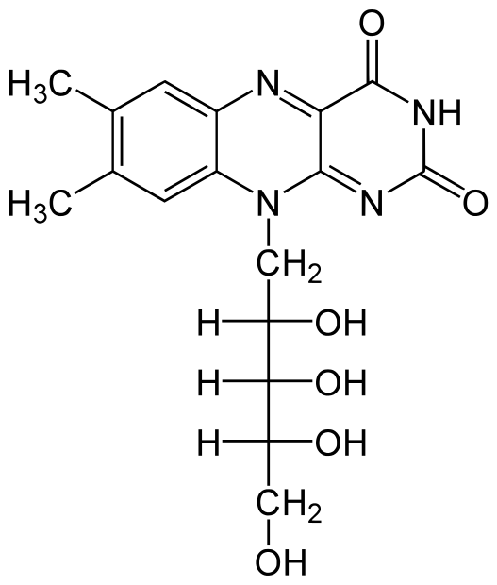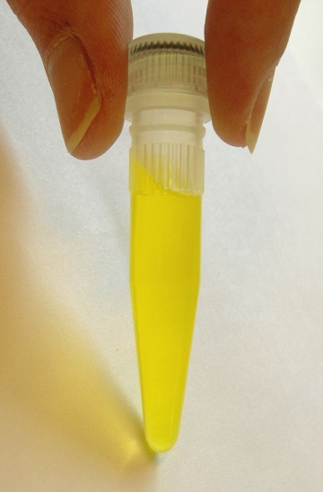
- Chemical Structure of Riboflavin (Vitamin B₂)
- Solution of Riboflavin
The paper provided (LC with UV absorbance detection) is one method that can be used for this analysis. Your lab partner also suggests that riboflavin in urine can be measured by precipitating the proteins from urine and directly analyzing the supernatant for riboflavin by fluorescence.

- Which method of analysis would you choose and why? Be sure to describe important criteria in an analytical technique and discuss the advantages and disadvantages of each method.
- Based on the method you selected in part A, what type of calibration will you use to determine the amount of riboflavin in the urine sample (external standards, internal standards, or standard addition). Explain your choice.

